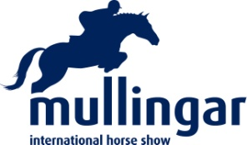

SHOWING SHOW

Ring 1 -
Ridden Hunters, 10.00 am start sharp

Class 1 Small Hunter,
Class 2 Lightweight Hunter,
Class 3 Medium / Heavyweight Hunter,
Class 4 Riding Horse,
Class 5 Ridden Cob,
Class 6 Racehorse to Riding Horse, Tattersals’s Qualifier sponsored by the IHWT,
Class 7 Ridden Irish Draught,
Class 8 Intermediate Show Hunter / Show Riding Type up to 158 cm,
Class 9 Mountain & Moorland Large Breeds (inc Connemara),
Class 10 Side Saddle (open to all), affiliated to the Side Saddle Association
Class 11 Local Riding Class (open to riders in Westmeath who have not won a class in 2017)

- Champion Ridden Horse / Pony

Ring 2 -
Equifestival Working Hunter Qualifier, 11.00 am start sharp

Class 12 Evt 1. 60 cms (Ponies to qualify only),
Class 13 Evt 2. 70 cms,
Class 14 Evt 3. 80 cms (inc Cob Qualifier),
Class 15 Evt 4. 90 cms,
Class 16 Evt 5. 1 M,
Class 17 Evt 6. 1.10 M

- Champion Working Hunter
First & Second prizewinner from each WH class are eligible for the championship

ENTRIES:

Please contact Andrina / Richard on 085 8430747

Postal entries to:
Hunter Secretary, Mullingar Equestrian Centre, Athlone Road, Mullingar, Co Westmeath

