Mullingar Equestrian Centre

New Year Derby Show

Sunday January 6th @ 10.15
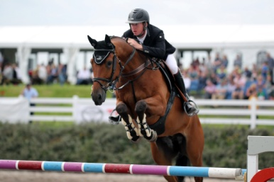
Schedule of Classes
- X poles / 40cm @ 10.30 am
- 50cm @ 11.30 am
- 60cm @ 12
Events 1 -3 : Entry Fee €10 ( Event 1 to 2 ) , School pony plus €15
- 60cm Full Derby
- 70cmDerby (under 18 ) @ from 1 pm
70cm (18yrs +)
- 80cm Derby (under 18) @ 2 pm
80cm (18 yrs+ )
- 90cm Derby @ 3.30 pm,
- Metre Events 4 to 9 :Entry Fee €15, school pony €20
*****************************************

Sunday League starts January 13th 20th 27th & , Feb 3rd ( Final )
Schedule for Sunday league as above
Entry fee €10 / €15 in 60cm & below ) Entry Fee €15, school pony €20 ( 70cm plus)
- League Winners Prize in each class on the final day
- Must attend 2 shows to be eligible for final day prize .

